Travel report
I am Davaakhuu Tserendorj 3rd year Ph.D. students in Environmental Science in Faculty of Science. I was attended at 15th Carpathian Basin Conference for Environmental Science
(XV. KÁRPÁT-MEDENCEI KÖRNYEZETTUDOMÁNYI KONFERENCIA), from 3-6th of April 2019 in Cluj-Napoca, Romania. Davaakhuu Tserendorj presenting her poster presentation during the conference. Therefore, she was two other poster presentation co-authors during the conference (picture of titles with authors attached below) and abstract book also attached with this report).
The purpose of the conference is share present study results, networking with scientists, study and improve our abilities and motivation as well.
I won the grant for registration fee and accommodation, it was 46000 forints. I am uploading some necessary documents and pictures included in travel report.

- POSTER PRESENTED AT 15TH CARPATHIAN BASIN CONFERENCE FOR ENVIRONMENTAL SCIENCES CONFERENCE, CLUJ 2019

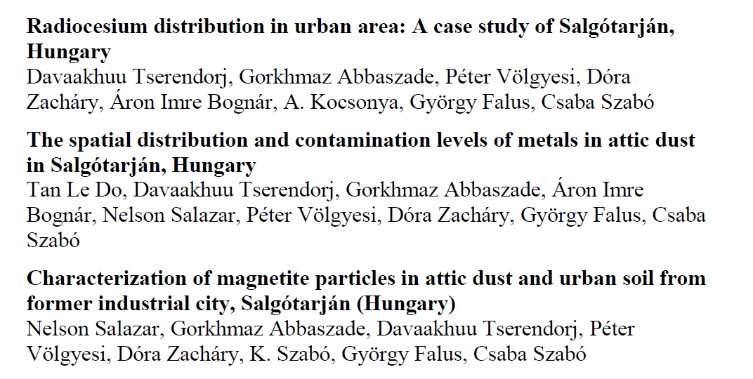

- Registration bag with name card identification
